Part A: Theory & Definitions

1. Define the following with examples from the dataset:
Types of data: Numerical & Categorical
Data in statistics is mainly divided into Numerical and Categorical data.

🔹 Numerical Data
Numerical data consists of values that can be measured or counted and are expressed in numbers. Mathematical operations (addition, average, etc.) can be performed on them.
Examples from the dataset:
- Age_of_Household_Head → e.g., 35, 52, 68
- Household_Income → e.g., 25,000; 60,000; 1,10,000
- Family_Size → e.g., 2, 4, 6
✔ These values represent quantities and can be used to calculate mean, median, variance, etc.

🔹 Categorical Data
Categorical data represents labels, groups, or categories. It describes qualities or characteristics and cannot be used for mathematical calculations.
Examples from the dataset:
- Household_ID → HH0001, HH0025
- Education_Level → Primary, Secondary, Graduate, Post-Grad
- Owns_House → Yes / No
- Urban_Rural → Urban / Rural
✔ These values classify households into different groups.

Types of Statistics: Descriptive vs. Inferential
Statistics is broadly classified into Descriptive Statistics and Inferential Statistics.

🔹 Descriptive Statistics
Descriptive statistics focuses on summarizing and organizing data to understand its main features.
Examples from the dataset:
- Average household income
- Maximum and minimum age of household heads
- Count of urban vs rural households
- Percentage of households owning a house
✔ It describes what the data shows.

🔹 Inferential Statistics
Inferential statistics uses sample data to make predictions or conclusions about a population.
Examples related to the dataset:
- Predicting average income of all households based on the 500-sample data
- Testing whether urban households earn more than rural households
- Estimating population income using confidence intervals
✔ It explains what we can conclude beyond the data.

What is Descriptive Statistics?
Definition:
Descriptive statistics is the branch of statistics that deals with collecting, organizing, summarizing, and presenting data in a meaningful way.
Common descriptive measures:
- Mean, Median, Mode
- Minimum, Maximum
- Standard Deviation
- Frequency tables and graphs
Example from the dataset:
- Calculating the average age of household heads
- Finding the most common education level
- Displaying income distribution using a histogram
- Counting how many households own a house
✔ Descriptive statistics helps us understand the dataset without making predictions.

2. Explain the difference between:
Mean, Median, Mode
Range, Variance, Standard Deviation

A) Mean, Median, and Mode
These are measures of central tendency (they show the center of the data).

🔹 Mean
Definition:
The mean is the average value of a dataset.
Formula:
Mean = (Sum of all values) ÷ (Number of values)
Example (Household_Income):
If incomes are: 20,000; 30,000; 50,000
Mean = (20,000 + 30,000 + 50,000) / 3 = 33,333
✔ Sensitive to very high or very low values.

🔹 Median
Definition:
The median is the middle value when data is arranged in ascending or descending order.
Example (Age_of_Household_Head):
Ages: 30, 35, 40, 45, 60
Median = 40
✔ Not affected by extreme values (outliers).

🔹 Mode
Definition:
The mode is the value that appears most frequently in the dataset.
Example (Education_Level):
If “Secondary” appears most often → Mode = Secondary
✔ Can be used for categorical data.

📌 Key Differences (Mean vs Median vs Mode)
Measure | Meaning | Affected by Outliers | Example Field
Mean | Average | Yes | Household_Income
Median | Middle value | No | Age_of_Household_Head
Mode | Most frequent | No | Education_Level

B) Range, Variance, and Standard Deviation
These are measures of dispersion (they show data spread).

🔹 Range
Definition:
Range is the difference between the maximum and minimum values.
Formula:
Range = Max − Min
Example (Family_Size):
Max = 7, Min = 1
Range = 6
✔ Very simple but ignores overall distribution.

🔹 Variance
Definition:
Variance measures how far each value is from the mean, on average.
Formula (Conceptual):
Variance = Average of squared deviations from the mean
Example (Income):
Large variance → incomes are widely spread
Small variance → incomes are similar
✔ Units are squared, making interpretation harder.

🔹 Standard Deviation
Definition:
Standard deviation is the square root of variance.
Why important?
It shows data spread in the same unit as the data.
Example (Household_Income):
SD = 10,000 → most incomes vary by about ₹10,000 from the mean
✔ Most commonly used dispersion measure.

📌 Key Differences (Range vs Variance vs Standard Deviation)
Measure | What it Measures | Unit
Range | Total spread | Same as data
Variance | Average squared spread | Squared unit
Standard Deviation | Average spread from mean | Same as data

3. Explain the following term with neat and clean diagram along with its formula:
Gaussian Distribution

Definition
A Gaussian Distribution, also called a Normal Distribution, is a continuous probability distribution that is symmetrical and bell-shaped around its mean.
Most natural and real-life data (such as height, marks, IQ, measurement errors) approximately follow a Gaussian distribution.

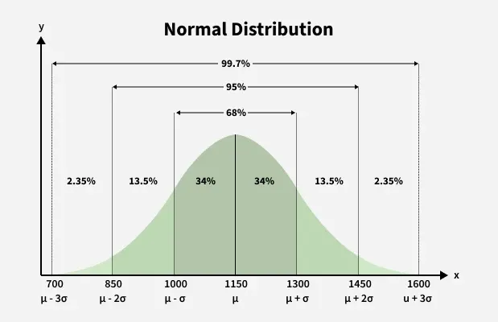

Key Characteristics
- Bell-shaped and symmetric curve
- Mean = Median = Mode
- The curve is highest at the mean
- Total area under the curve = 1
- Tails approach but never touch the X-axis

Gaussian Distribution Formula
$$f(x)=\frac{1}{σ\sqrt{2π}} e^{-\frac{\left(x − μ)^{2}\right.}{2σ^{2}}}$$

Where:
Symbol | Meaning
$$x$$ | Random variable
$$μ$$ | Mean
$$σ$$ | Standard Deviation
$$π$$ | Constant (≈ 3.1416)
$$e$$ | Euler’s number (≈ 2.718)

Log Normal Distribution
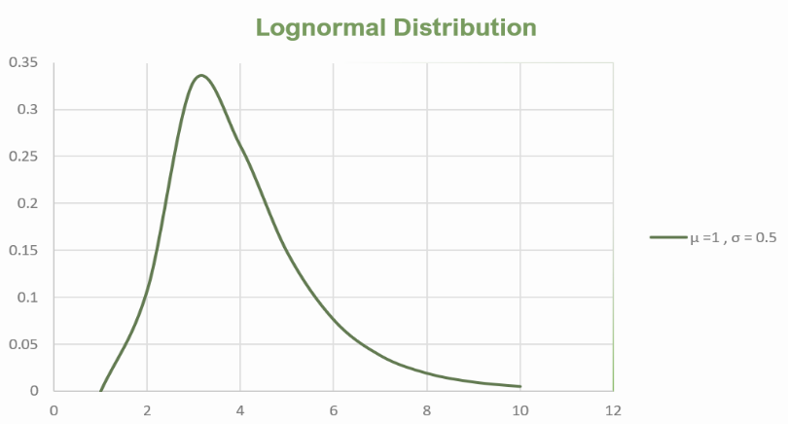

Definition
A Log-Normal Distribution is a continuous probability distribution in which the logarithm of the random variable follows a normal (Gaussian) distribution.
If
$$Y=ln⁡(X)$$
is normally distributed, then X is log-normally distributed.

Key Characteristics
- Positively skewed (right-skewed)
- Values are always positive ($X>0$)
- Mean > Median > Mode
- Common in real-world growth processes

Log-Normal Distribution Formula
$$f(x)=\frac{1}{x σ\sqrt{2π}}exp⁡\left( − \frac{\left(ln⁡x-μ)^{2}\right.}{2σ^{2}}\right),x>0$$

Where:
Symbol | Meaning
$$x$$ | Random variable
$$μ$$ | Mean of $ln⁡(x)$
$$σ$$ | Standard deviation of $ln⁡(x)$
$$ln⁡$$ | Natural logarithm
$$e$$ | Euler’s constant
3-Sigma Rule or Empirical Rule
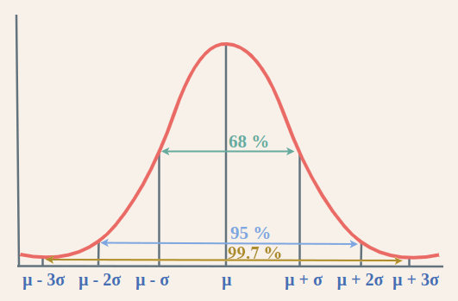

Definition
The 3-Sigma Rule, also known as the Empirical Rule, states that for a normally distributed (Gaussian) dataset, almost all observations lie within three standard deviations of the mean.

Statement of the Rule
For a Normal Distribution:
Range | Percentage of Data
μ ± 1σ | ≈ 68%
μ ± 2σ | ≈ 95%
μ ± 3σ | ≈ 99.7%
This is why it is called the 68–95–99.7 Rule.

Percentiles

Definition
A percentile is a measure that indicates the value below which a given percentage of observations in a dataset falls.
👉 The pᵗʰ percentile is the value such that p% of the data is less than or equal to it.

Key Points
- Used to understand relative position in a dataset
- Divides data into 100 equal parts
- Helps compare individual performance

Percentile Formula (Ungrouped Data)
$$\text{Position of }P_{p}=\frac{p}{100}×(n+1)$$
Where:
- $p$= required percentile
- $n$= total number of observations

Steps to Find Percentile
- Arrange data in ascending order
- Calculate position using formula
- If position is fractional, interpolate between values

Example
Data (sorted):
10, 20, 30, 40, 50, 60, 70, 80, 90
Find 40ᵗʰ percentile:
$$P_{40}=\frac{40}{100}×(9+1)=4$$
👉 4ᵗʰ value = 40
So, 40 is the 40ᵗʰ percentile.

Neat Diagram
Data Distribution (Ordered)

0% 25% 50% 75% 100%
|------|-------|-------|--------|
Min Q1 Median Q3 Max
(P25) (P50) (P75)

Important Percentiles
Percentile | Meaning
P25 | First Quartile (Q1)
P50 | Median
P75 | Third Quartile (Q3)
P90 | Top 10% cutoff
P95 | High performers

Quartiles

Definition
Quartiles divide an ordered dataset into four equal parts, with each part containing 25% of the data.
They help in understanding data spread, central tendency, and variability.

Types of Quartiles
Quartile | Symbol | Meaning
First Quartile | Q₁ | 25% of data lies below
Second Quartile | Q₂ | 50% of data lies below (Median)
Third Quartile | Q₃ | 75% of data lies below

Quartile Formula (Ungrouped Data)
$$Q_{1}=\frac{\left(n + 1\right)}{4} \\ Q_{2}=\frac{\left(n + 1\right)}{2} \\ Q_{3}=\frac{3(n+1)}{4}$$
Where:
- $n$= number of observations

Steps to Find Quartiles
- Arrange data in ascending order
- Calculate positions of Q₁, Q₂, Q₃
- If position is fractional, interpolate

Example
Data (sorted):
10, 20, 30, 40, 50, 60, 70, 80, 90
- $n=9$
$$Q_{1}=\frac{10}{4}=2.5⇒\frac{20+30}{2}=25 \\ Q_{2}=\frac{10}{2}=5⇒50 \\ Q_{3}=\frac{30}{4}=7.5⇒\frac{70+80}{2}=75$$

Neat Diagram
Ordered Data Distribution

Min Q1 Q2 Q3 Max
|-------|---------|---------|----------|
25% 50% 75%

Interquartile Range (IQR)
$$\text{IQR}=Q_{3}-Q_{1}$$
👉 Measures spread of middle 50% data

Outlier Detection Using Quartiles
$$\text{Lower Bound}=Q_{1}-1.5×IQR \\ \text{Upper Bound}=Q_{3}+1.5×IQR$$
Values outside this range are outliers.

Five Number Summary

Definition
The Five Number Summary is a set of five descriptive statistics that provide a complete overview of a dataset’s distribution, including its center, spread, and range.

The Five Numbers
Statistic | Symbol | Meaning
Minimum | Min | Smallest value
First Quartile | Q₁ | 25% of data lies below
Median | Q₂ | Middle value (50%)
Third Quartile | Q₃ | 75% of data lies below
Maximum | Max | Largest value

Steps to Find Five Number Summary
- Arrange data in ascending order
- Identify Minimum and Maximum
- Find Q₁, Median (Q₂), and Q₃ using quartile formulas

Example
Data (sorted):
10, 20, 30, 40, 50, 60, 70, 80, 90
- Min = 10
- Q₁ = 25
- Median (Q₂) = 50
- Q₃ = 75
- Max = 90

Neat Diagram (Box-Plot Representation)
Min Q1 Median Q3 Max
|------|==========|============|----------|
25% 50% 75%

Interquartile Range (IQR)
$$IQR=Q_{3}-Q_{1}$$
👉 Measures spread of the middle 50% of data

Outlier Detection
Using IQR method:
$$\text{Lower Bound}=Q_{1}-1.5×IQR \\ \text{Upper Bound}=Q_{3}+1.5×IQR$$
Values outside this range are outliers.

Why Five Number Summary is Important
- Gives quick overview of data
- Helps detect skewness & outliers
- Basis for box plots
- Easy comparison between datasets

Applications
- Exploratory Data Analysis (EDA)
- Exam score analysis
- Salary distribution
- Data science & statistics

Skewness
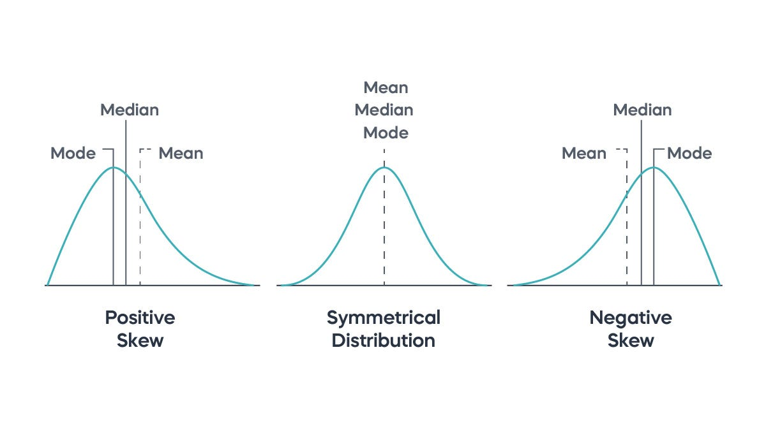

Definition
Skewness is a measure of asymmetry of a probability distribution around its mean.
It tells us whether the data is symmetric, right-skewed, or left-skewed.

Types of Skewness
Type | Description
Zero Skewness | Symmetric distribution
Positive Skewness | Right-skewed (long right tail)
Negative Skewness | Left-skewed (long left tail)

Skewness Formula

Karl Pearson’s Coefficient
$$\text{Skewness}=\frac{\text{Mean}-\text{Mode}}{\text{Standard Deviation}}$$
If mode is not available:
$$\text{Skewness}=\frac{3(\text{Mean}-\text{Median})}{\text{Standard Deviation}}$$

Moment Coefficient of Skewness
$$γ_{1}=\frac{\frac{1}{n}∑(x_{i}-\overset{ˉ}{x})^{3}}{σ^{3}}$$

Interpretation
Value | Meaning
Sk = 0 | Symmetric
Sk > 0 | Positively skewed
Sk < 0 | Negatively skewed

Example
- Income distribution → Positive skewness
- Exam scores (very easy paper) → Negative skewness
- Height of students → Approximately symmetric

Why Skewness is Important
- Helps understand data shape
- Influences mean & median
- Important in statistical modeling
- Helps choose correct statistical tests

Relation with Mean, Median, Mode
Distribution | Relation
Symmetric | Mean = Median = Mode
Positive skew | Mean > Median > Mode
Negative skew | Mean < Median < Mode

Kurtosis
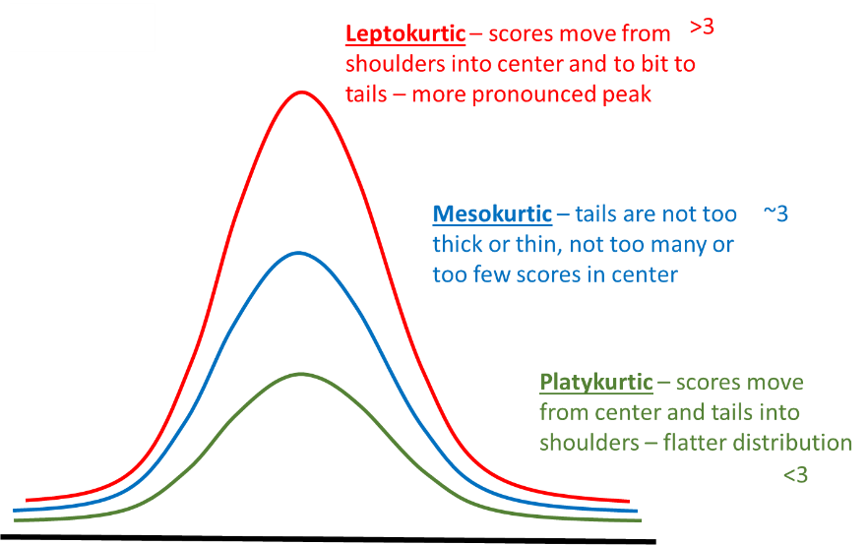

Definition
Kurtosis is a statistical measure that describes the peakedness and tail heaviness of a probability distribution relative to a normal distribution.
👉 It tells us how extreme values (outliers) are likely to occur.

Types of Kurtosis
Type | Description
Mesokurtic | Normal peak (Gaussian)
Leptokurtic | Sharp peak, heavy tails
Platykurtic | Flat peak, light tails

Skewness Formula

Karl Pearson’s Coefficient
$$\text{Skewness}=\frac{\text{Mean}-\text{Mode}}{\text{Standard Deviation}}$$
If mode is not available:
$$\text{Skewness}=\frac{3(\text{Mean}-\text{Median})}{\text{Standard Deviation}}$$

Moment Coefficient of Skewness
$$γ_{1}=\frac{\frac{1}{n}∑(x_{i}-\overset{ˉ}{x})^{3}}{σ^{3}}$$

Interpretation
Value | Meaning
Sk = 0 | Symmetric
Sk > 0 | Positively skewed
Sk < 0 | Negatively skewed

Example
- Income distribution → Positive skewness
- Exam scores (very easy paper) → Negative skewness
- Height of students → Approximately symmetric

Why Skewness is Important
- Helps understand data shape
- Influences mean & median
- Important in statistical modeling
- Helps choose correct statistical tests

Relation with Mean, Median, Mode
Distribution | Relation
Symmetric | Mean = Median = Mode
Positive skew | Mean > Median > Mode
Negative skew | Mean < Median < Mode

